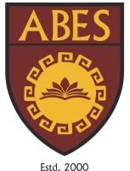ABES ENGINEERING COLLEGE CCPD TECH DEPARTMENT PROJECT

**Project Id**: IT/A/001

**Project Title**: Online Learning Platform

**Project Description** : Create an online learning platform where users can register for courses, track their progress, and view educational content. The platform should include video lessons, quizzes, and a progress dashboard.

**Key Features to Implement:**

1. Course registration form
2. Video lesson player
3. Quizzes with progress tracking
4. Dashboard for course progress
5. Responsive design(optional)

**Timeline**: 5 Week(s)

**Technology needs to used:**

|  |  |  |  |  |  |  |  |  |  |
| --- | --- | --- | --- | --- | --- | --- | --- | --- | --- |
| S. No | **Html 5** | | | **CSS3** | | | **Java Script** | | |
| 1 | Div/span | form | video | Display/position | Grid,  style | Pseudo- class | Async,  Await | Form  validation | Reduce |